Lab 7
Ashmitha Murali
Prof. Alex Yang
Verilog HDL Lab EE461L
12th November 2025

- The fastest clock frequency achievable is 76.923MHz as shown below.
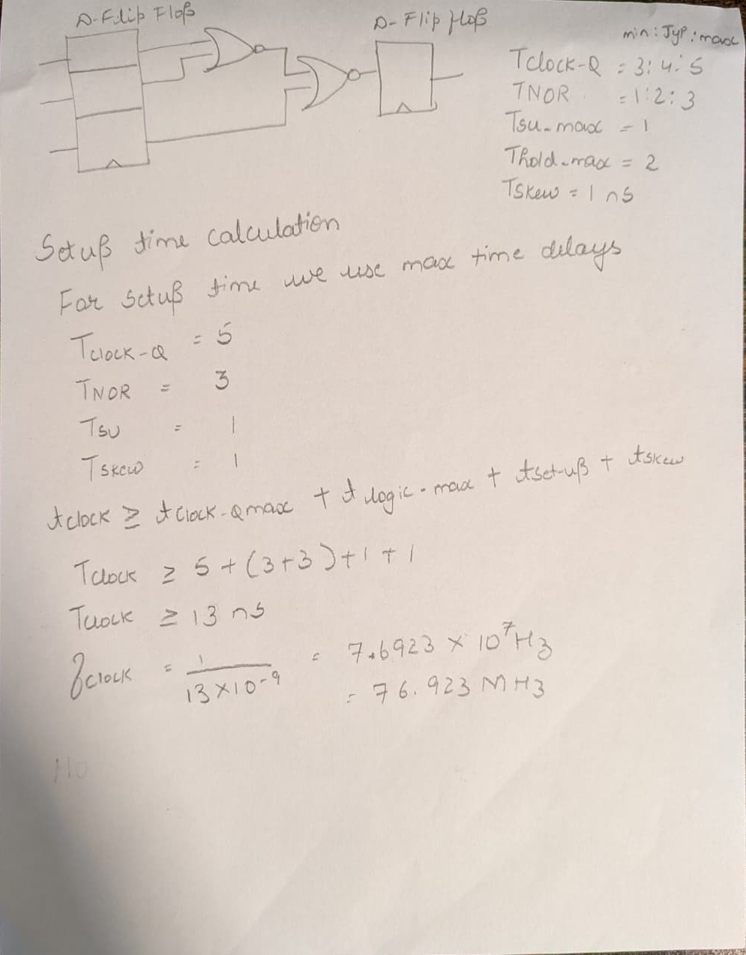
Since the hold time equation satisfies, there is no possibility of a hold time violation.
